## Rapid Pattern Library: Multi-screen multi-input rapid prototyping framework

## Project Architecture

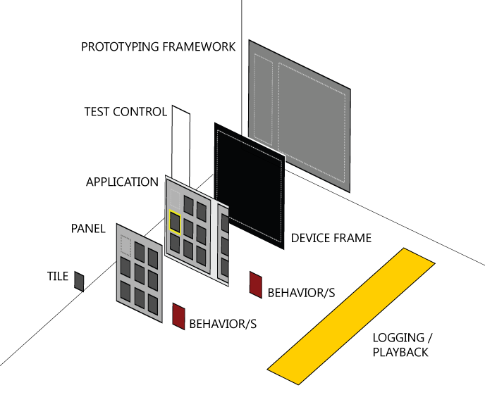

## Prototype Framework

Entire test bed. Host for the Session Control Panel and the Device Frame

## Session Control Panel

Mechanism to start and stop the trial, access to any configuration options. Connection to the logging system.

## Device Frame

Host for the Applications. Host for any hardware device buttons.

## Application

Top level application organizer

## Panel

Grouping of tiles that mostly moves together. Host to layout behaviors etc.

## Tile

Lowest level of customizable functionality.

## Behaviors

Attachable patterned code snippets that can assist with input, layout, etc. Very convenient means to add code to an application without requiring any coding experience of the users of the functionality.

## Logging / Playback

Mechanism for logging and playing back tests. All events timestamped.

|  |  |  |  |
| --- | --- | --- | --- |
| **PART** | **Code Location** | **DESIGNER ACTIVITIES** | **DEVELOPER ACTIVITIES** |
| Prototyping Framework | MetroLibraryTest_XXX | Save Project as Template  Add Device Frame | Connect to other Frameworks |
| Session Control Panel | SessionControl | Define Start State  Define End State  Define Errors States  Define Pop-up Messages  Host User Input Boxes | Add new top level Log events. |
| Device Frame | MetroLibrary  Eg. PhoneDevice | Change Appearance  Add Application  Create additional devices | Support new input mechanisms |
| Application | TileSL/MetroPanel  Eg. Start Experience | Change Appearance  Add Panels / Tiles  Apply Interaction Behaviors  Apply Layout Behaviors  Describe States | Add additional logging events |
| Panel | TileSL/MetroPanel | Change Appearance  Add Panels / Tiles  Apply Interaction Behaviors  Apply Layout Behaviors | Create new layout behaviors  Support new input mechanisms |
| Tile | TileSL/Tile | Use Standard Tile Types  Define New Tile Content  Add Logging via LogBehavior  Change Tile Style  Apply Interaction Behaviors  Connect to Data Sources | Create New Custom Tiles |
| Behaviors | MetroLibrary  Eg. FishEyeBehavior | Apply to Application  Apply to Panel  Apply to Tile | Create new Interaction Behavior  Create new Layout Behavior |
| Logging Playback | SessionControl | Add SessionControlPanel to any User Control  Add Log Behavior | Create new MEF Logging Backend  Create new LogBehavior  Add new Log Events to LogBehavior |

## Prototype Component Deliverables

Packages (Re usable/distributable DLL)

* MetroLibrary
* TileSL
* SessionController

Behaviors: Interaction/Layout (MetroLibrary)

* CustomCursorBehavior
* BarnDoorBehavior
* FishEyeBehavior
* FlowTransitionBehavior
* GridLayoutBehavior
* KeyPressNavigationBehavior
* MouseNavigationBehavior
* ParallaxBehavior
* ScrollNavigationBehavior
* StackLayoutBehavior

Multi-screen Shells (MetroLibrary)

* Phone
* Tablet

UI Objects (TileSL)

* MetroPanel
* Tile

Instrumentation (SessionController)

* UI Object
  + SessionControllPanel
* Behavior
  + LogBehavior (XML Output)
* Managed Extensibility Framework: integrated extensibility layer for future ‘plug ability’ in post prototype project augmentation (Details to follow)

Sample Project Files

Upcoming (reusable) ‘input’ prototyping components on deck:

* Kinect2PC: Camera input for PC
* Kinect2PC: input mapping utility
* SpeechBehavoir: voice input for PC